Booster Club Meeting

December 2nd, 2020

Prepared by Joni Schultz, Secretary

Attendees: Chad Colvert President, Tracy Behnken Vice President, James Bartels Treasurer, Joni Schultz Secretary, Heather Harkin Volunteer Coordinator, Michelle Holtz Concessions, Donita Diamond At Large, Malea Melis at Large, Sheryl Cornett At Large, Mr. Chris Kessel Athletic Director

Absent- Keo Jorgensen At Large,

 James reported on the treasurer’s report

|  |  |
| --- | --- |
| Clothing: | $12,225.16 |
| Concessions | $8293.00 |
| Membership | $14,292.27 |
| Savings | $48,656.04 |

Total $83,466.47

We have a few outstanding bills to pay for clothing purchases.

The event Bennington Gives that was promoted by the Bennington Community Foundation; several donations were given to the Booster Club.

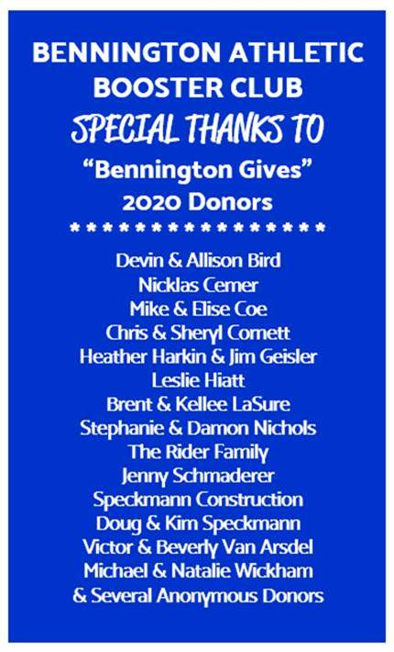

Tracy reported on the membership for the Booster Club.

|  |  |  |
| --- | --- | --- |
| 155 Individual members |  | $11,200 |
| 52 Corporate |  | $15,550 |
| Total |  | $26700 |

Amy reported on clothing. The beanies are in and the blankets will be arriving in a couple weeks. Amy is going to have a sale at the library December 12th from 9:30-11:30.

A few Board Members will be needed to help work the sale.

Squad locker 20% discount until December 6th.

Michelle discussed the concession stand.

She should not have to buy very much more inventory as we are stocked up from the leftovers from the football concessions.

Here is who is line up to help with the stands.

Concessions:

Amy Jaap- Jv & v girls

Devon Bird -Jv & v boys

Tracey Behnken - Wrestling

There is a wrestling meet this weekend. The wrestling club is going to run the stand. 60/40 split.

Heather reported that the sign -up genius is ready for signups for the winter sports.

It was decided that anything with 2 games the stand will be open.

Mr. Kessel -no requests from the school for requests.

Joni Schultz would like to stay on as an At Large Board Member. With her new schedule for her job, she is not sure she would be able to attend all of the meetings so she would like to resign as the secretary.

James Bartels also would like to resign from the treasurer’s position.

Heather Harkin has served as the volunteer coordinator and her son will be graduating so she also would like to resign from the board.

Discussion was had on how to recruit for board members. It was decided that posts will be made on social media and the remind app.

Meeting adjourned at 7:07.

The next meeting is January 6th at the High School.