Booster Club Meeting March 3, 2021 Joni Schultz, Secretary
Attendees: Chad Colvert President, Tracy Behnken Vice President, James Bartels Treasurer Joni Schultz Secretary, Amy Douglas Apparel, Heather Harkin Volunteer Coordinator, Keo Jorgensen at Large, Donita Diamond At large, Michelle Holtz Concession Stand, Sheryl Cornett At Large
Absent- Malea Melis At Large

Guests-Megan Detjens, Andrea Foltz, Leslie Hiatt, Dr. Bloomenkamp
Absent: Keo Jorgensen

Two employees from Daktronics came and presented to the Booster Club on digital scoreboards.
Many schools in the area have these high definition scoreboards and the Booster Club is looking to donate this to the school. The boards can be used for sporting events as well as graduation, movie nights, ect.

A few of the benefits of going with this company is:

- Curriculum for educational development-
Daktronics also provides a curriculum to the school as a class so that kids can learn more about this technology and decide if they have interest in this and would like to pursue this field in the future.

- They are a local company. If we had issues with the boards, they could be out here to fix very quickly.

- They would help us fund raise if that is the direction we chose to go.

- The boards could be paid for over a 5-year time frame

They presented to the Booster Club several different options.

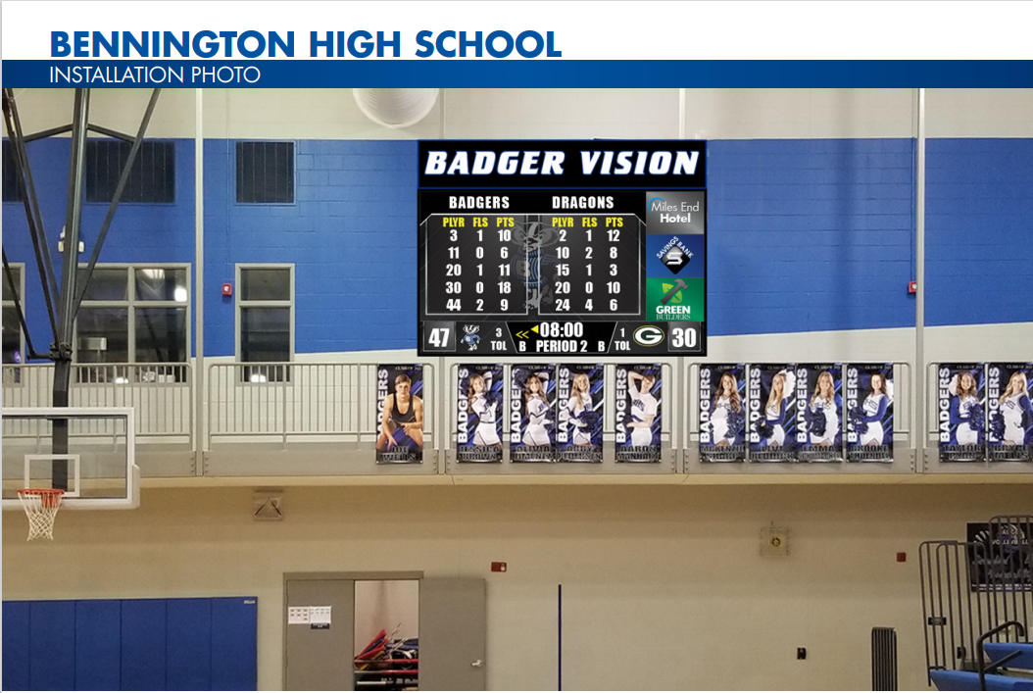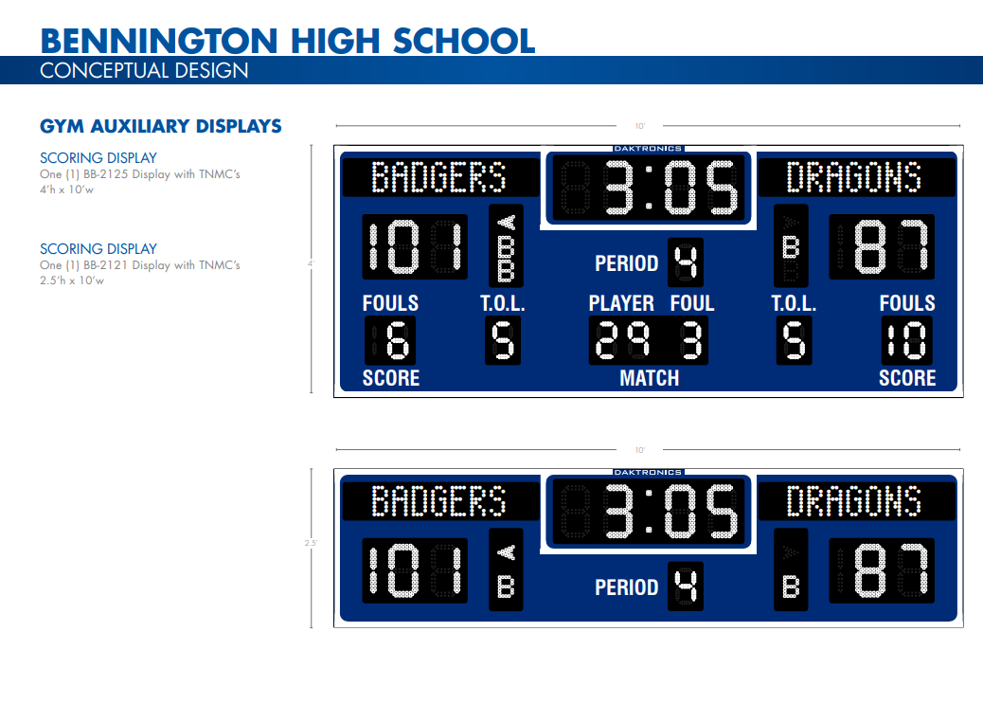

Examples from other schools:

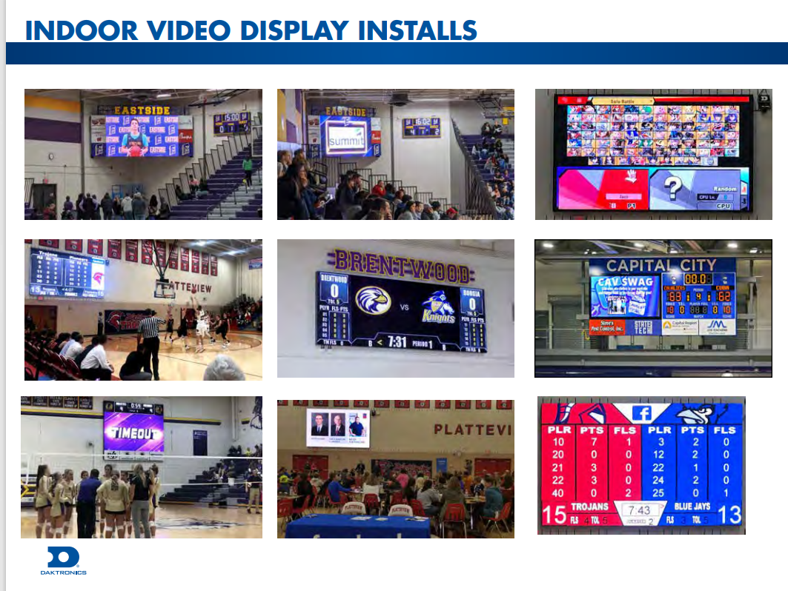

3 options proposed:

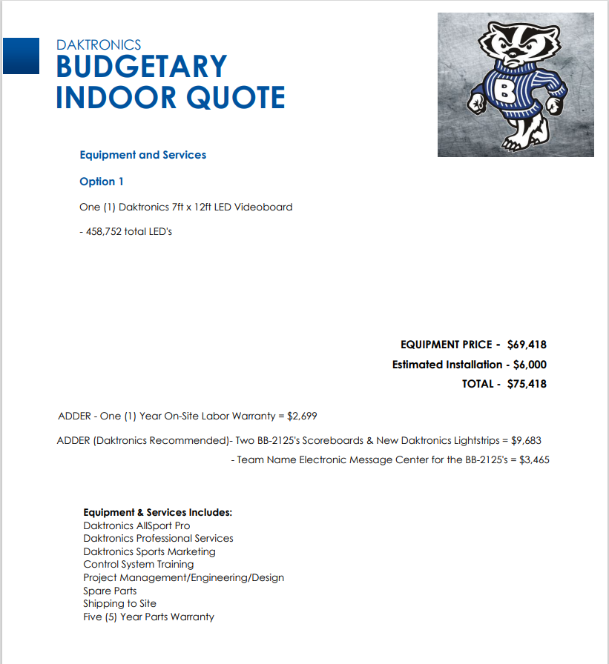

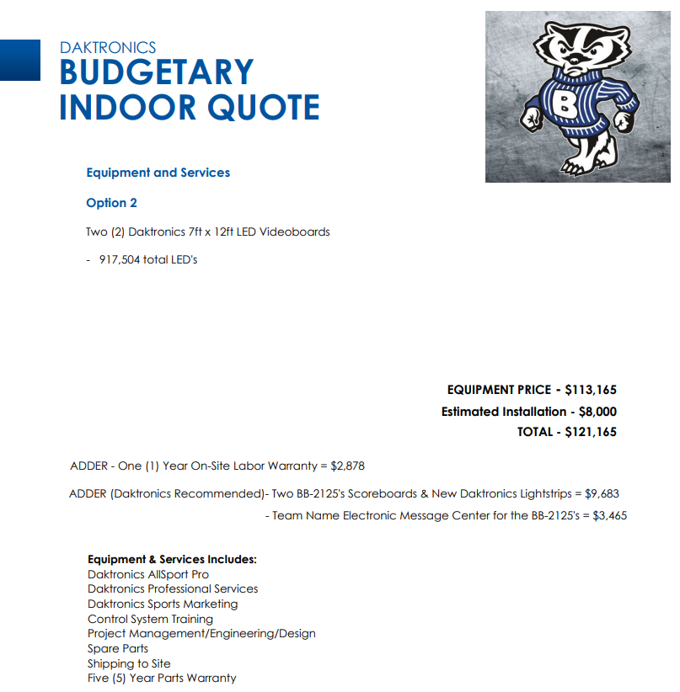

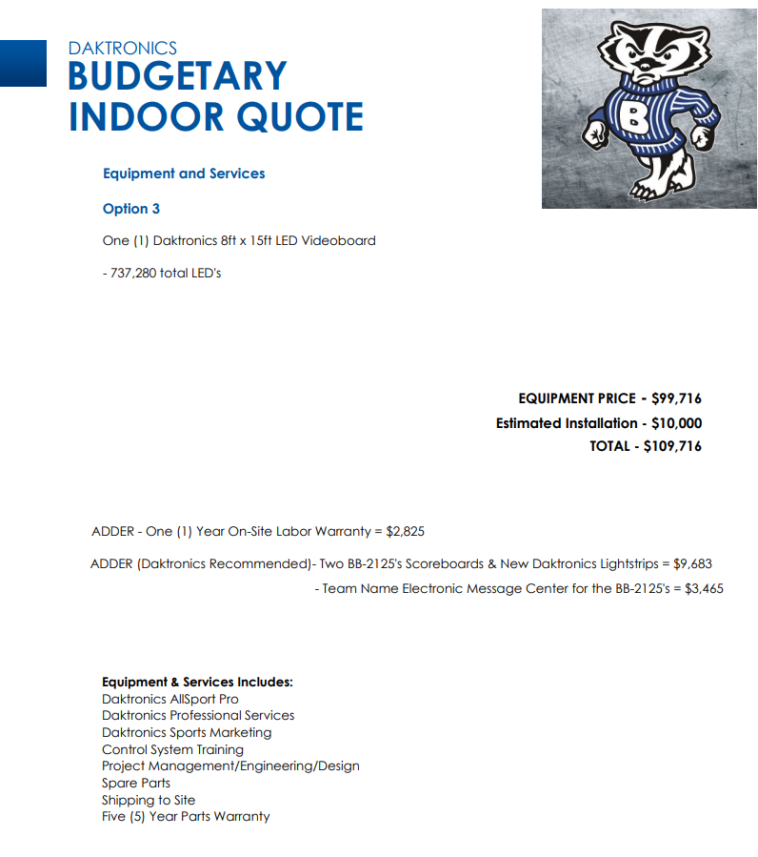

Discussion on process of purchasing these new boards was discussed.

Discussion on how to pay for these boards.
- High school pay for the video board
- High School and Booster Club split the cost if sponsors/advertisements are allowed
- Booster Club would pay for the whole project if sponsors/advertisements are allowed
  - Discussion with Dr. Blomenkamp on how we get permission to have advertising on the board during the events. Currently the school does not allow this. To do a fundraising event or ask for sponsors/advertisements -we would need permission from the school to spotlight businesses/corporations that donated or sponsored. Dr. Blomenkamp stated that a meeting with Dr. Haack would be the first step. Dr. Haack could then decide he wanted to bring this to the school board for permission for their decision. Chad is going to request a meeting with Dr. Haack and if he approves, then Chad will get on the agenda for the next school board meeting.

A decision must made by May so that the boards can be made in time for the Fall Season.
It was brought up this could be a win for the school because they could take down the current scoreboards and relocate them to the new Middle School which would then save the school money. Also, these new boards come with a warranty for 5 years and that also would be beneficial to the school and save their funds on fixing board issues as they have seen in the past.

The Booster Club Board discussed that we more than likely will not continue on this project if the school will not let us obtain sponsorships for the video board or if the school is unwilling to partner in the cost of this project.

James gave the treasurers report. The Booster Club has no accounts payable at this time.

Clothing | $21,258.55
Concessions | $9,073.59
Membership | $14,489.81
Savings account | $48,679.50
Total | $93,501.45

James stated that the Booster Club is $23,000 down in revenue from last year because of concession stand income.

Tracey reported on membership.
As of today:
157 | Members | $11350
52 | Corporate sponsors | $15550

$1,312 Bennington Gives through the Bennington Community Foundation was donated.

Amy reported on apparel:
$285 was made off wrestling apparel

The Booter Club will hold a spring sale April 20th at the track meet in Bennington. She is in the process of ordering new items.

Michelle discussed the concession stands for the Spring Sports.

The Booster Club Board Members on March 11th are going to clean out the High School gym concessions stand and bring all supplies and inventory to the track concession stand.
On March 13th, the board members will clean out the baseball stadium and start to restock.

Money boxes for spring events:
James -Boys soccer
Malia –Girls soccer
Joni- Track
Heather- Baseball

-
We still need to find someone to take over for Michelle as Concession Stand Chair.

The Volunteer Coordinator Heather worked with Megan tonight on the spring sports schedule. Megan will be taking over for Heather at the end of this school year.

The next meeting is April 7th with elections of Board Members taking place.

Motion adjourned at 8:20 p.m.

